Academic Year: 2025-26 | Year: Second Year | Term: I
Roll No.: 1012411011 | Name: Riddhee Kulkarni
Subject: Java
Assignment No.: 9 | Title: Hospital Management System
Date: 30/09/2024

Aim: Write a program to connect to a database using JDBC, execute a simple SQL query, and display the results. Implement JDBC connectivity for Hospital management system. (No need of GUI creation for this system)

Theory:
JDBC Connectivity:
JDBC (Java Database Connectivity) is an API in Java that allows applications to connect to and interact with relational databases. It provides a standard interface for sending SQL queries, updating data, and retrieving results. JDBC uses drivers specific to each database (like MySQL, Oracle, PostgreSQL) to establish the connection.
SQL Query:
SQL (Structured Query Language) is used to interact with databases. Through queries, you can:
Retrieve data (using SELECT)
Insert new records (INSERT)
Update existing records (UPDATE)
Delete records (DELETE)

Flowchart:
Start
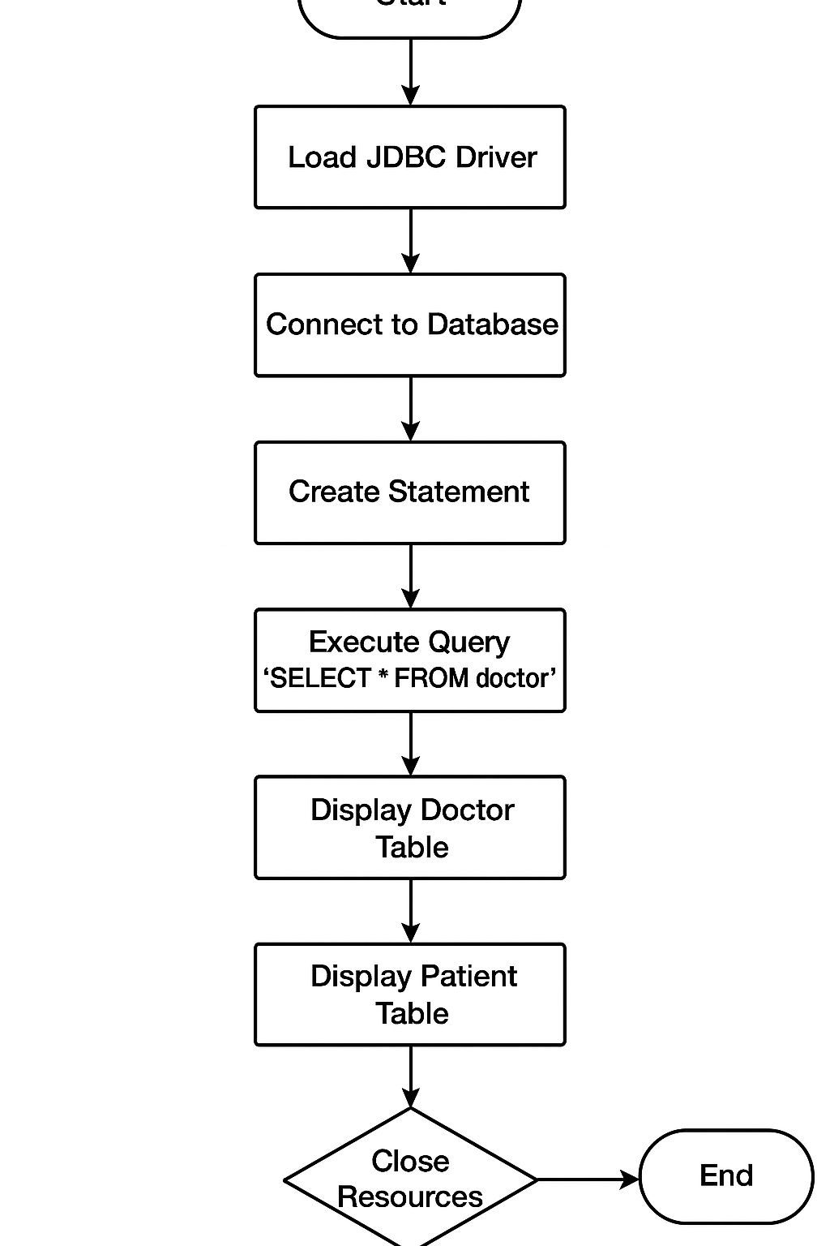
Code:

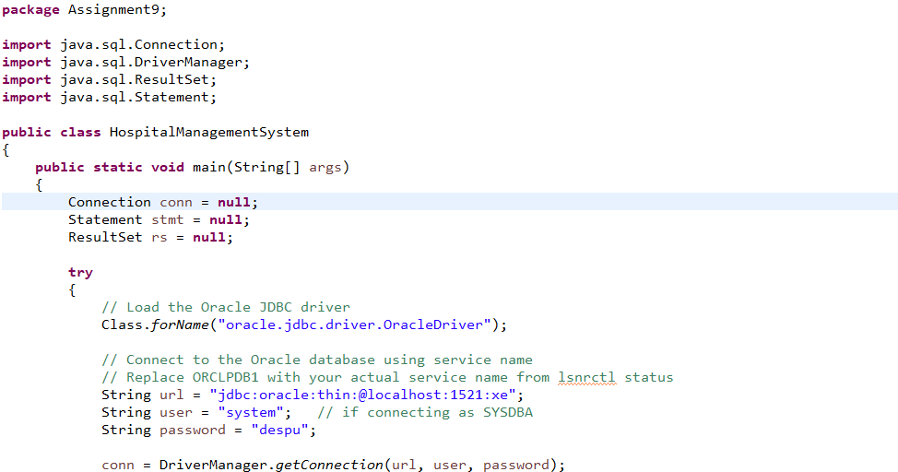
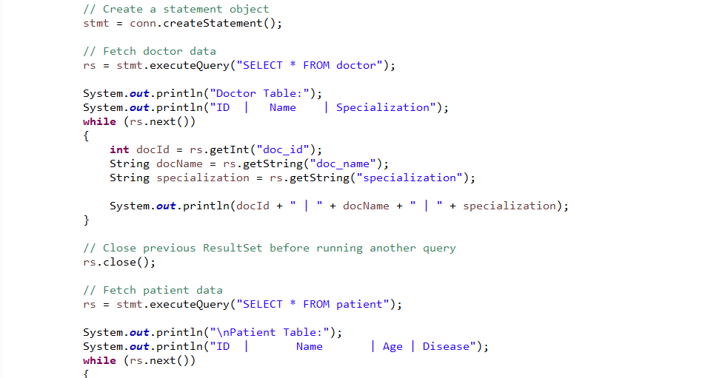
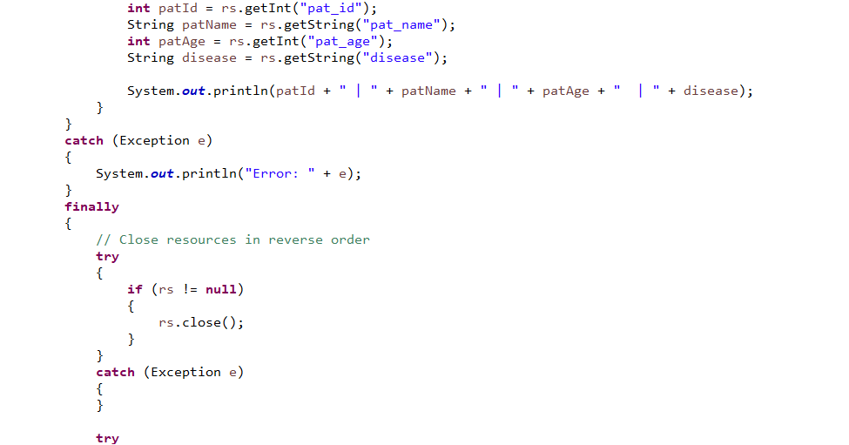
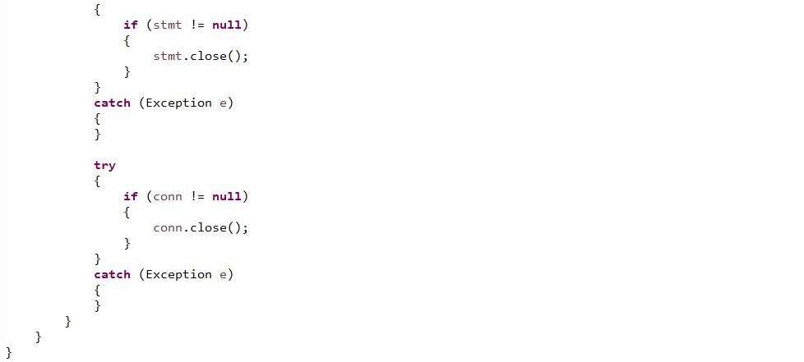
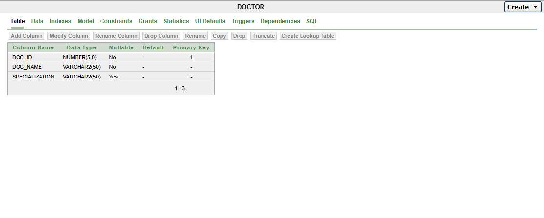
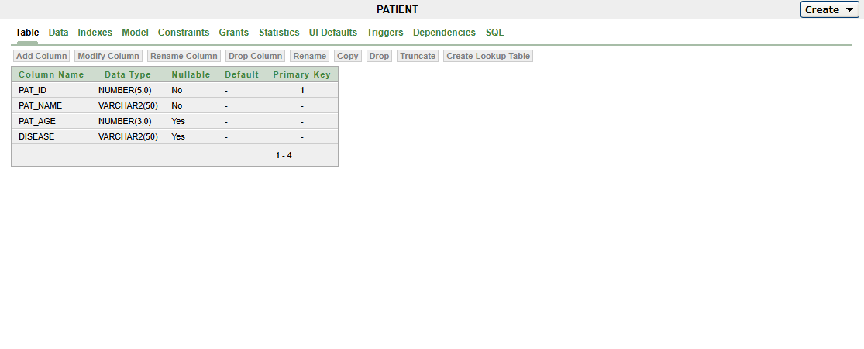

Output:
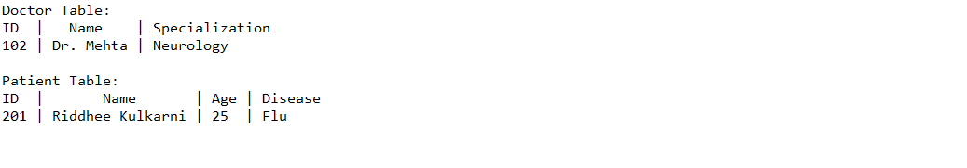
Conclusion:
The program connects to an Oracle database, retrieves doctor and patient data, displays it, and closes all resources properly.

